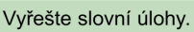
1.
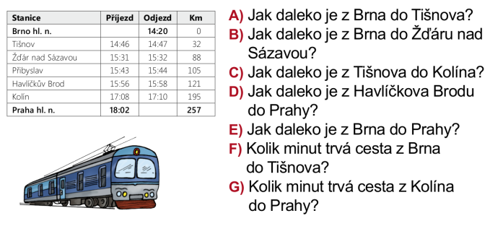
_______________________________________________________________________________________________
_______________________________________________________________________________________________
_______________________________________________________________________________________________
_______________________________________________________________________________________________
2.
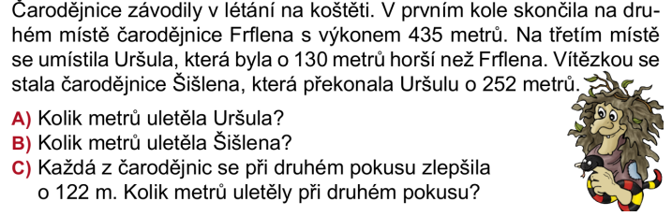_______________________________________________________________________________________________
_______________________________________________________________________________________________
_______________________________________________________________________________________________
_______________________________________________________________________________________________

3.
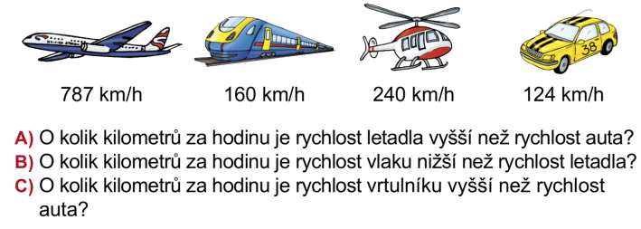_______________________________________________________________________________________________
_______________________________________________________________________________________________
_______________________________________________________________________________________________
_______________________________________________________________________________________________

4.
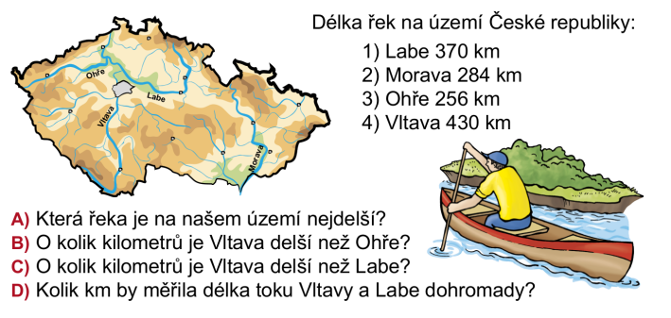_______________________________________________________________________________________________
_______________________________________________________________________________________________
_______________________________________________________________________________________________
______________________________________________________________________________________________

5.
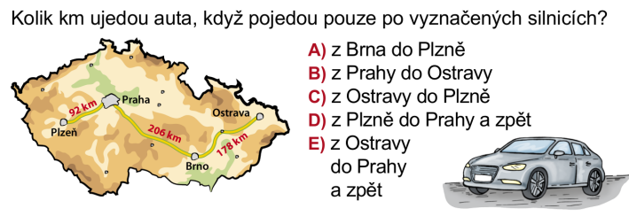_______________________________________________________________________________________________
_______________________________________________________________________________________________
_______________________________________________________________________________________________
_______________________________________________________________________________________________

6.
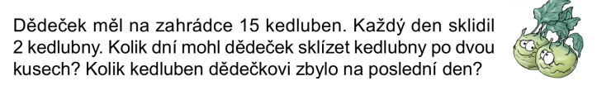_______________________________________________________________________________________________
_______________________________________________________________________________________________
7.
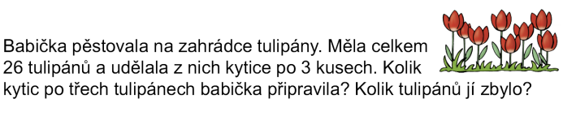
_______________________________________________________________________________________________
_______________________________________________________________________________________________

8.
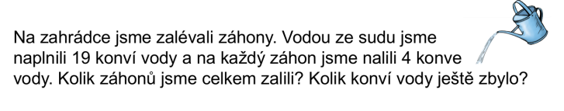_______________________________________________________________________________________________
_______________________________________________________________________________________________
9.
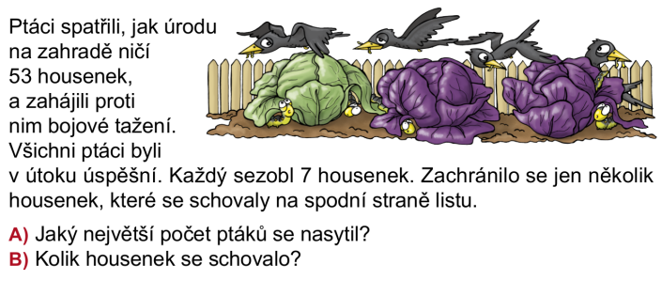_______________________________________________________________________________________________
_______________________________________________________________________________________________

10.
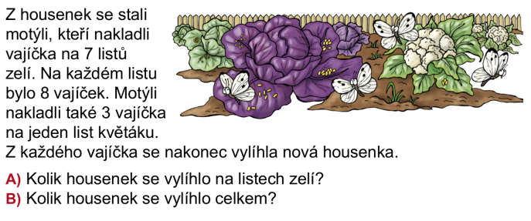_______________________________________________________________________________________________
_______________________________________________________________________________________________
11.

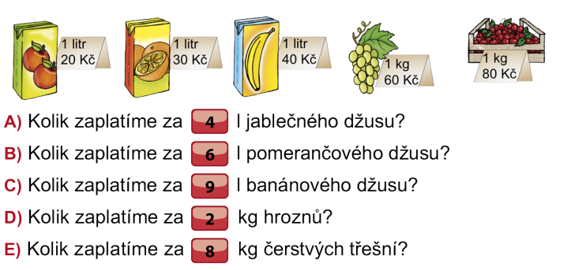_______________________________________________________________________________________________
_______________________________________________________________________________________________
_______________________________________________________________________________________________
_______________________________________________________________________________________________
12.
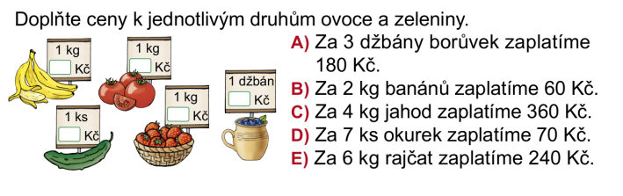_______________________________________________________________________________________________
_______________________________________________________________________________________________
_______________________________________________________________________________________________
_______________________________________________________________________________________________

13.
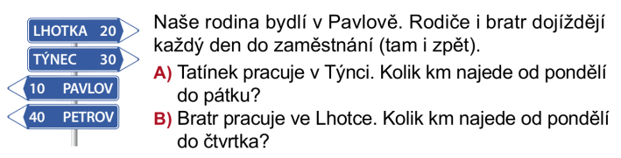_______________________________________________________________________________________________
_______________________________________________________________________________________________

14.
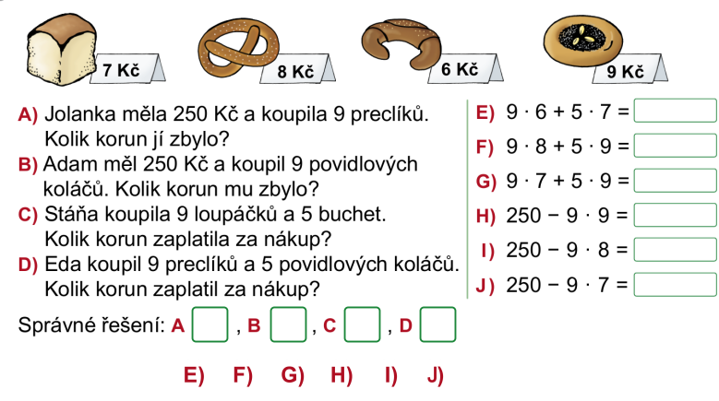
_______________________________________________________________________________________________
_______________________________________________________________________________________________
_______________________________________________________________________________________________
_______________________________________________________________________________________________
_______________________________________________________________________________________________
_______________________________________________________________________________________________
_______________________________________________________________________________________________
15.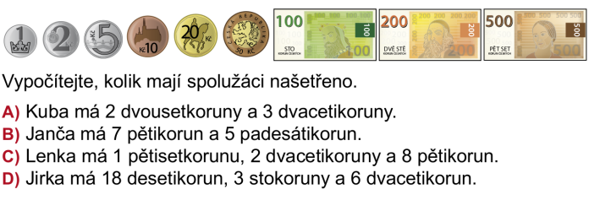 _______________________________________________________________________________________________
_______________________________________________________________________________________________
_______________________________________________________________________________________________
_______________________________________________________________________________________________

16.
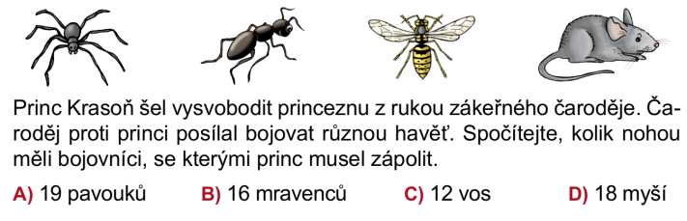

_______________________________________________________________________________________________
_______________________________________________________________________________________________
_______________________________________________________________________________________________
_______________________________________________________________________________________________

17.
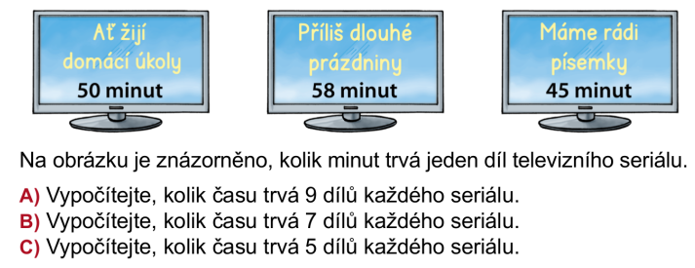_______________________________________________________________________________________________
_______________________________________________________________________________________________
_______________________________________________________________________________________________
_______________________________________________________________________________________________

18.

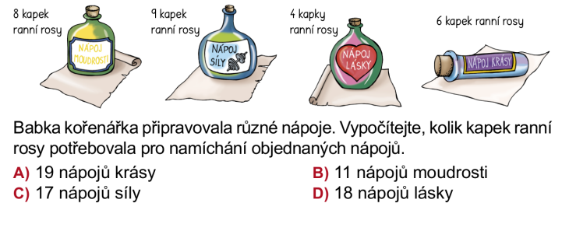_______________________________________________________________________________________________
_______________________________________________________________________________________________
_______________________________________________________________________________________________
_______________________________________________________________________________________________

19.

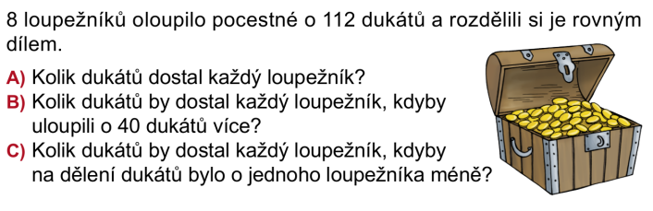
_______________________________________________________________________________________________
_______________________________________________________________________________________________
_______________________________________________________________________________________________
_______________________________________________________________________________________________

20.






