SHOULD / SHOULDN’T EXERCISES
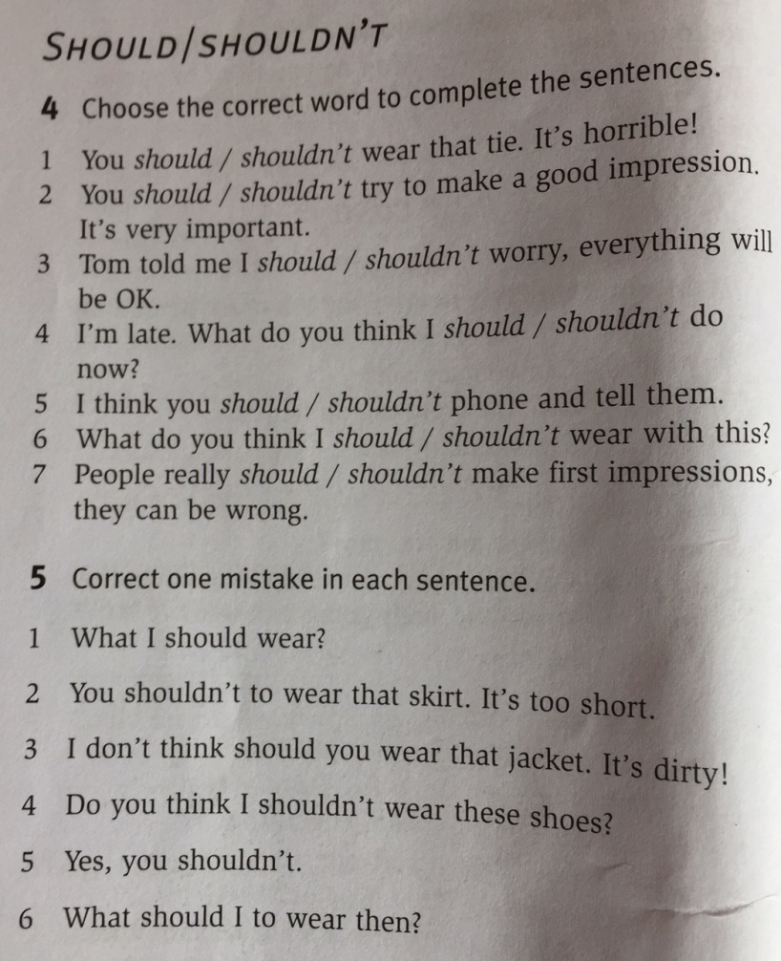
Give advice to Tony:
He wants more money. I think you should work harder. I think you should find a better job.
or
I don’t think he should buy every new game that comes out.
He’s tired in the morning. I think …………………………………………………………………………….
He wants to lose some weight. ………………………………………………………………………………
He wants to be a pro footballer. ……………………………………………………………………………..
He wants to have nice white teeth. ………………………………………………………………………….
He wants a girlfriend, but he only wears dirty clothes. I don’t think ………………………………………
He wants a new car, but he doesn’t have money. …………………………………………………………..
He wants a new faster car, but he isn’t a good driver. ……………………………………………………..

