will X be going to
video: https://www.youtube.com/watch?v=PL3fWJxvfLc

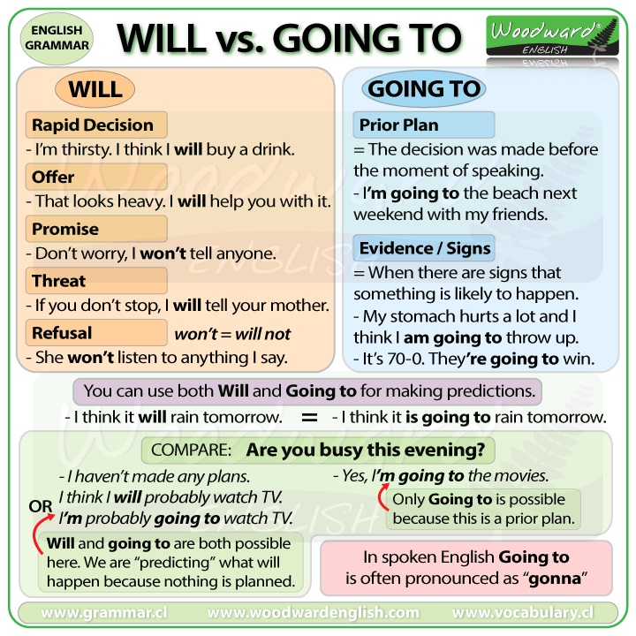

exercises:
https://agendaweb.org/exercises/verbs/future/will-going-to-2
https://agendaweb.org/exercises/verbs/future/will-going-to-3
http://digitalcampus.free.fr/Level2/Unit22/SubUnit222/ComplSentQCM.jqz.htm
http://esl.fis.edu/grammar/quiz/4.htm
https://www.montsemorales.com/gramatica/Willorbegoing4-5.htm

