FUTURE TENSE
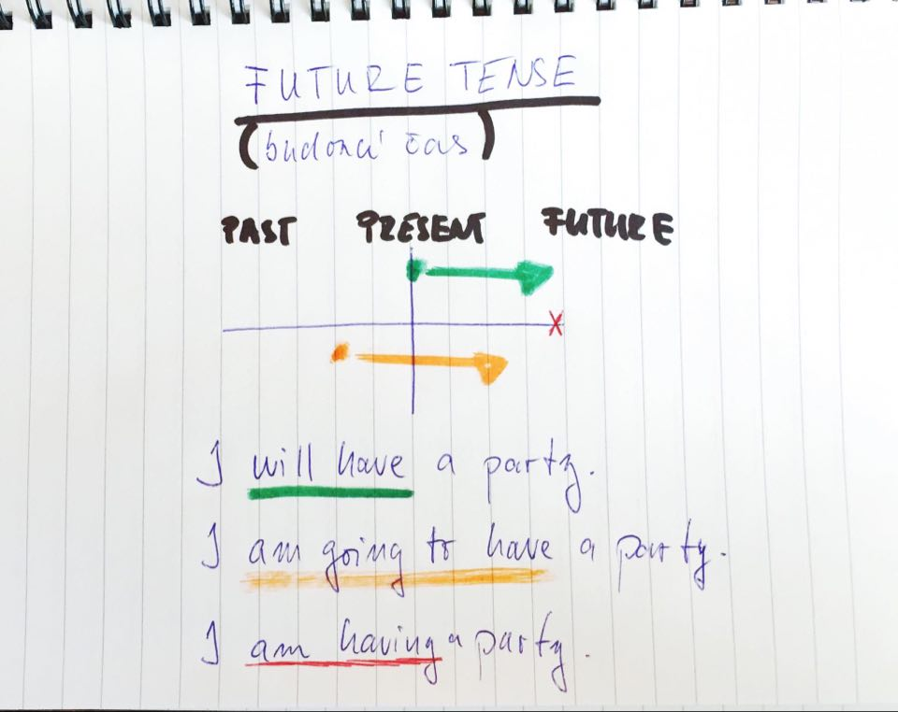

SIMPLE FUTURE – will

♦ vyjadřuje domněnky, předpovědi, reakci na novou informaci, sliby …
♦ tvoření: will / won‘t + infinitiv slovesa

+ She will help you.
– She won’t help you.
? Will she help me? Yes, she will. / No, she won’t.

♦ will se v běžné komunikaci zkracuje na ‘ll → I’ll, You’ll, We’ll …

FUTURE – be going to
♦ vyjadřuje promyšlenou budoucnost, záměr …
♦ tvoření: am / is / are going to + inf.
+ I am going to buy a new car.
- They aren’t going to win this game.
? Is she going to study for the test? Yes, she is. / No, she isn’t.

♦ v hovorové angličtině se going to často zkracuje na „gonna“
I’m gonna do it right now.

simple future video: https://www.youtube.com/watch?v=hz4-LkCEHCU
simple future exercises: https://agendaweb.org/exercises/verbs/future/will-forms
https://agendaweb.org/exercises/verbs/future/will-positive-write
https://agendaweb.org/exercises/verbs/future/affirmative-interrogative-will
https://agendaweb.org/exercises/verbs/future/negative-will
https://agendaweb.org/exercises/verbs/future/will-yes-no-questions
https://agendaweb.org/exercises/verbs/future/will-positive-negative-questions-write
https://www.ego4u.com/en/cram-up/grammar/future-1-will/exercises
https://www.ego4u.com/en/cram-up/grammar/future-1-will/exercises?04

be going to video: https://www.youtube.com/watch?v=VpR8tlvJ7Fo
be going to exercises: https://agendaweb.org/exercises/verbs/future/going-to-forms
https://agendaweb.org/exercises/verbs/going-to-write
https://agendaweb.org/exercises/verbs/future/going-to-interrogative-forms
https://agendaweb.org/exercises/verbs/future/going-to-negative-forms
https://agendaweb.org/exercises/verbs/going-to-write-3
https://www.englisch-hilfen.de/en/exercises/questions/going_to_future.htm

