PRESENT CONTINUOUS 6. A surname:_______________
- Make –ing forms (gerund)
swim - …………………., work - …………………., dance - …………………., sit - …………………., go - …………………., smile - …………………., run - …………………., play - ………………….,

- Complete the sentences with am, is, are
Sara and Tony ………… reading books now. Sally ………… helping her mum in the kitchen. I ……… doing an English exercise. We ………… studying. My father ………… working in the garden.

- Complete the sentences with present continuous of the verbs in the brackets
I am eating my lunch now. (eat) They …………………….. in their room. (sleep) ………… Monica ………………. ? (cook) Sam and Pete …………………….. a car. (drive) She ………………………. on her PC. (work) The children …………………….. in the garden (run)

- Make positive / negative sentence and a question
+ Paul is playing football. – Paul isn’t playing football. ? Is Paul playing football?
………………………………… We aren’t studying History. …………………………………….
………………………………………………………………………….. Is she watching TV?
They are having a video call. ……………………………………………………………………………..

- Re-arrange the words to make sentences or questions
isn’t / to / going / she / school ……………………………………………………………………………..
Helen / the / washing / is / dishes ………………………………………………………………………….
table / the / father / setting / is / my / now …………………………………………………………………
dog / you / your / walking / are ?……………………………………………………………………………
am / my / bed / making / I …………………………………………………………………………………

- Write short answers
Is he working? No, she isn’t. Are they training? Yes, ……………… Is Frank sleeping? No, ……………
Are you doing an exercise? Yes, …………….. Is you father watching TV? No, ……………….
Are Marry and Jane studying? Yes, ………………. Is your dog playin with a ball? Yes, ………………..
- What are they doing? Look at the pictures and write sentences.
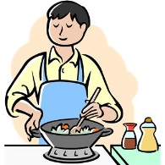 Mr Black is cooking dinner. 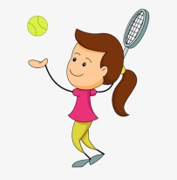 Fiona ………………………………………

 

